Lesson 5 – Designer
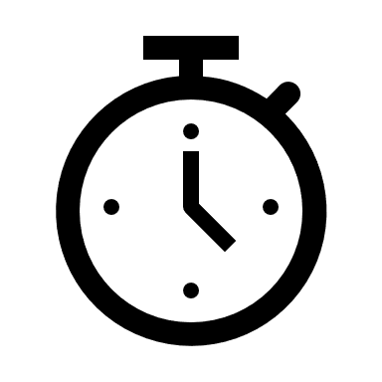2h

Talking about Designer
Design the first Screen.
Inserting and customizing Views: Labels, TextFields, Buttons, Panes
Saving forms
Design their own Main Screen using wireframes.

What students should know

Until now you have used the turtle to move it through the screen, and the log command to display information on the language log screen. What if you ask the program user to enter values? Or what happens when you want to display information to the user? The B4X has a special interface screen design environment. Through it you can design the appearance of the screens and generally communicate with the users of your application.
Every time you must design an app you should keep in mind that the look of your app is what will attract users to it. In other words, it is not enough to be simple functional but also easy to use as well as to offer information in an organized way without confusing.
Before designing any app remember some key design elements (usabilty.org, 2021):
Keep the interface simple. The best interfaces are almost invisible to the user. They avoid unnecessary elements and are clear in the language they use on labels and in messaging.
Create consistency and use common UI elements. By using common elements in your UI, users feel more comfortable and can get things done more quickly.
Strategically use color and texture. You can direct attention toward or redirect attention away from items using color, light, contrast, and texture to your advantage.
Use typography to create hierarchy and clarity. Carefully consider how you use typeface. Different sizes, fonts, and arrangement of the text to help increase scanability, legibility and readability.
Make sure that the system communicates what’s happening. Always inform your users of location, actions, changes in state, or errors.
Think about the defaults. By carefully thinking about and anticipating the goals people bring to your site, you can create defaults that reduce the burden on the user. This becomes particularly important when it comes to form design where you might have an opportunity to have some fields pre-chosen or filled out.

First steps with design
First of all, you should begin the B4J and now from file menu choose New and B4XPages. Choose a directory and write a name for your project. You will see the code bellow. There are two tabs of code here, the first one called Main and the second B4XMainPage.
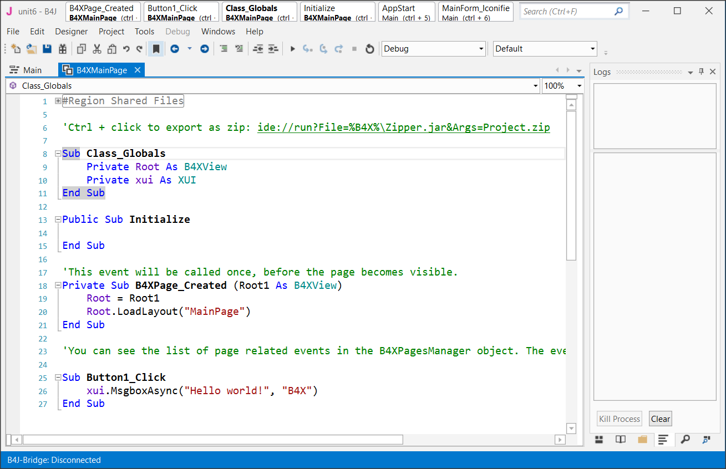
Do not worry about them now. We will discus later about them. Now all you need to know is that inside the B4XMainPage all the beautiful things happen for our code!
Now from the Designer menu select Open Internal Designer.
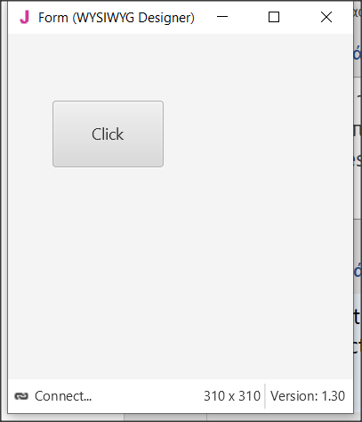
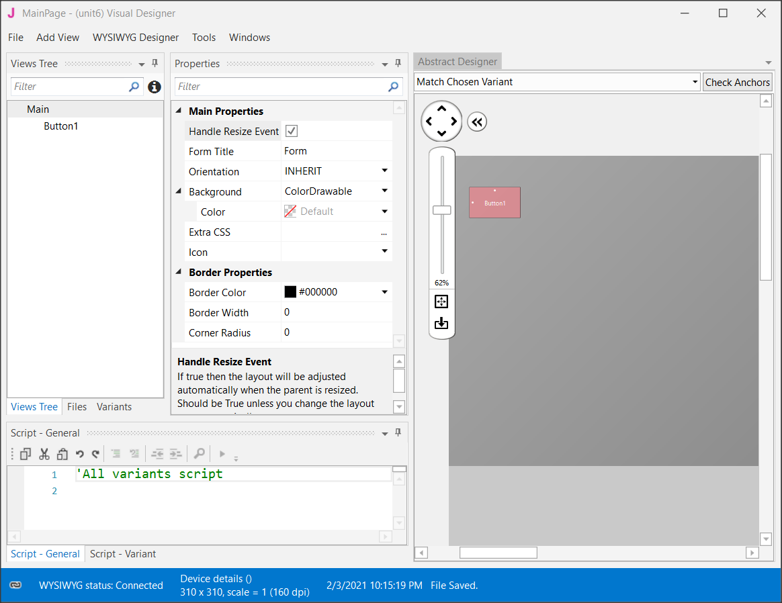
This is where the design process begins. Two windows will open, the first is the designer and the second is the preview of the screen you are designing.
Figure Designer Screen

Visual designer
The AddView menu includes all the objects needed to create our screen.
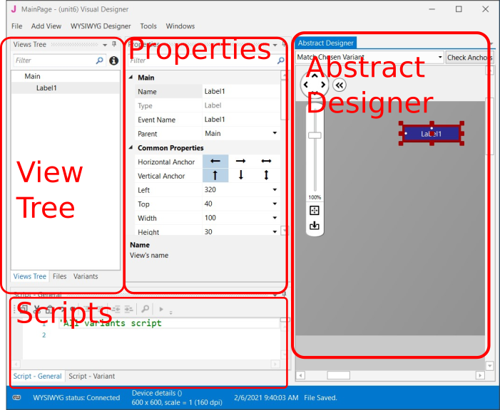
Select a label from the menu, and then move it to the preview screen where you decided before in the wireframe stage.
Remember
You can move all objects around the view by selecting them and holding the left mouse key.
Figure Designer's parts

The Views Tree
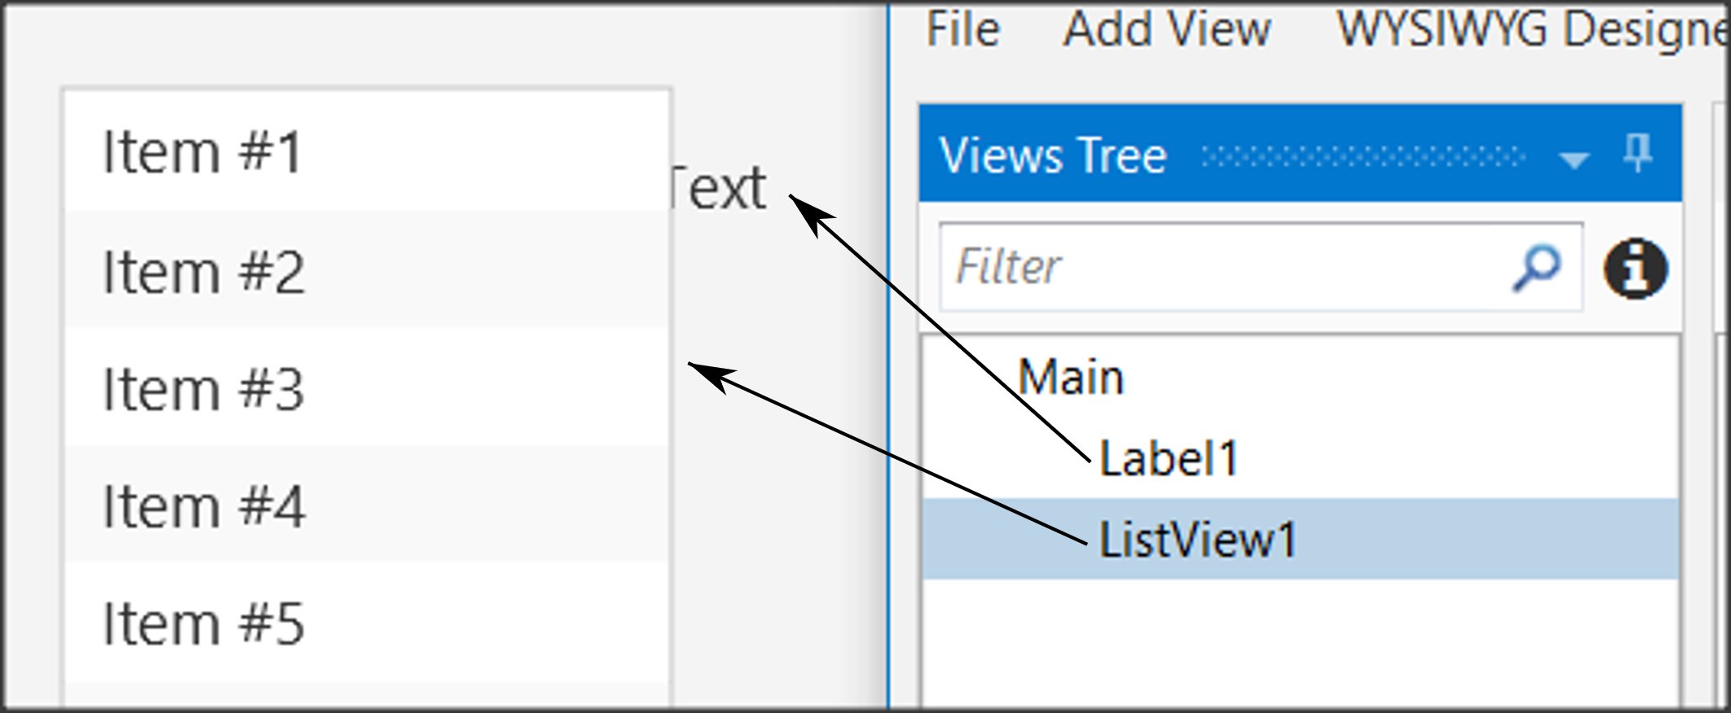
Here you see all the objects in your design. Keep in mind that the objects above the list are placed behind the next ones.
Figure Views Tree

Properties
Each object has properties such as size, screen position, colors, font, etc. Each property can be changed either through the properties option or later through the program code.
One of the most important properties is the name of the object. This, like variables, should follow specific rules to indicate their type. For example in Table 3 Naming objects some cases of names.
Type | Prefix | Example
Label | lbl | lblName
Button | btn | btnSave
TextField | txt | txtAge
Spinner | spn | spnYears
Pane | pn | pnLine1
Table 3 Naming objects

Abstract Designer
The Abstract Designer allows to select position and resize Views. It is a very useful function for quickly placing objects in the correct position (however the most accurate placement is made by the Properties tab by setting the relevant values).


Example 1
Imagine that you want to make a program that reads from the screen two Integers, calculates, and shows the sum.

Decide on the size of the app screen.
This depends on the amount of information we must display as well as on the individual items such as menus, graphics etc.

To set the application’s size before beginning the Designer first go to Main Tab and change the first lines of code Width and Height:
#Region Project Attributes
#MainFormWidth: 600
#MainFormHeight: 400
#End Region

Save your project and open Designer.

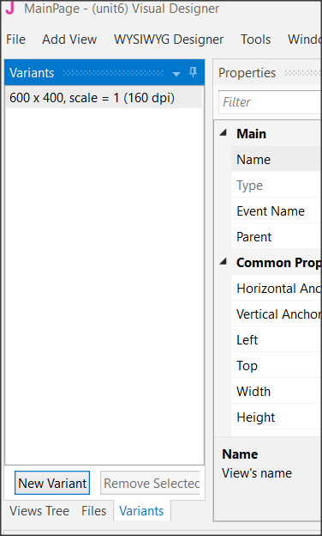
Set an appropriate variant.
Figure Variants Screen
Usually, you should set the variant as the MainFormWidth and MainFormHeight. This will help you plan without the risk of going outside the screen limits.
Choose Variants and then New Variant and set the width and height.
You can have as many variants as you want for different screen size but for now, we stay to only one. Also, you can remove any variant by selecting it and choosing “Remove Variant”.

Design a wireframe.
For small applications, this step is optional, but it is a good habit to have decided from the beginning where you want to display your details. You can use a simple sheet of paper or several programs to help create previews.
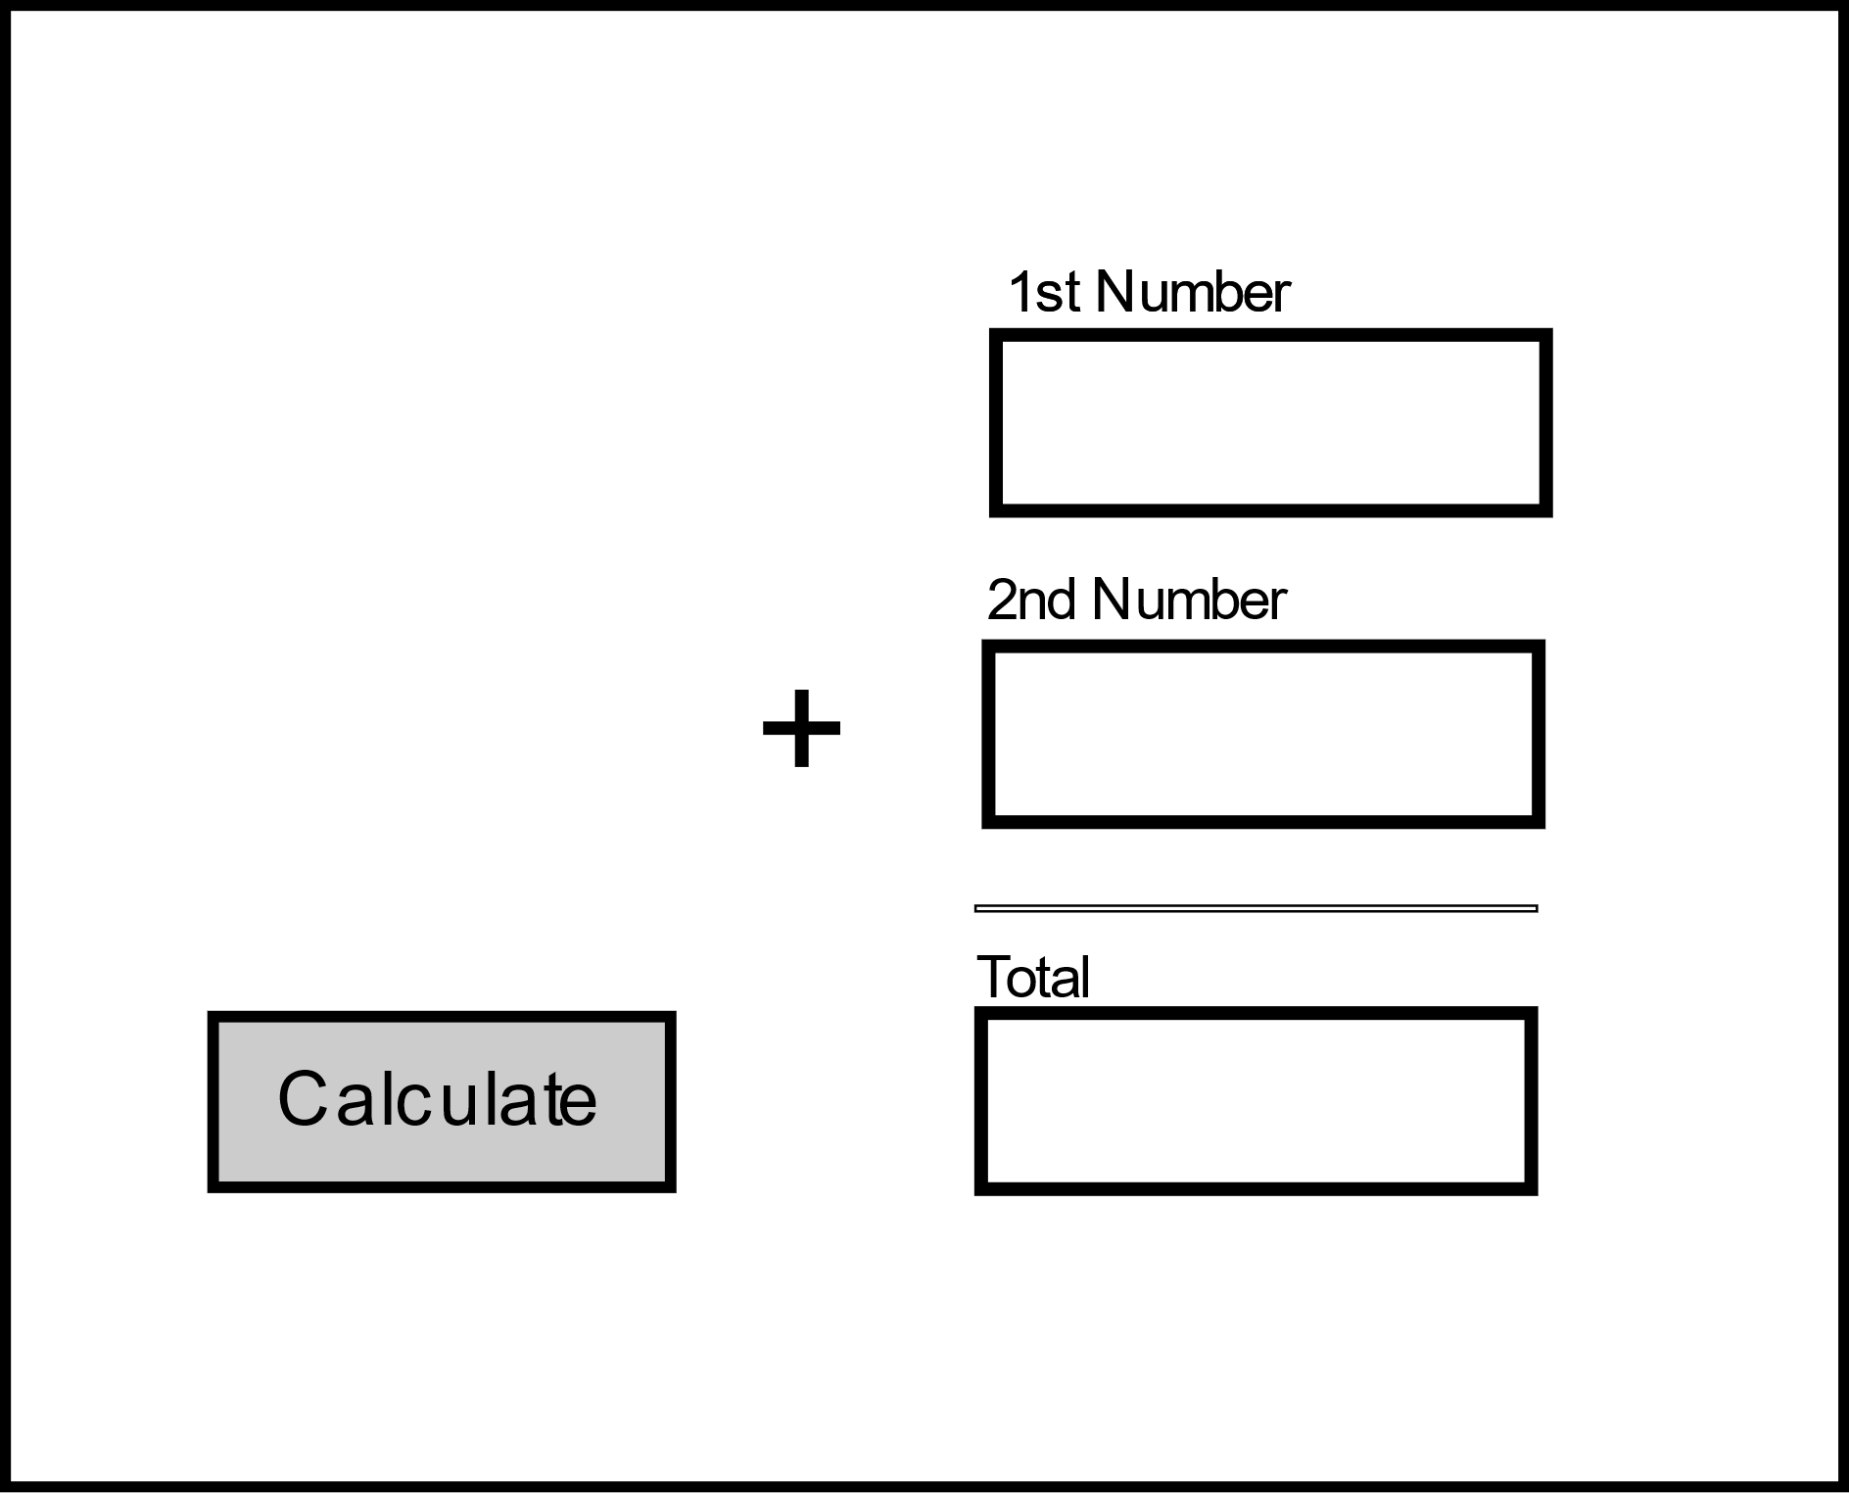
Button
Text Box

Label
Figure 8 Wireframe

Create the views.
Now that you know what you need and where to place it, use the Designer tools to complete the process.

Inserting a label.
From View menu select label and you will see a label object in your View Tree and in the Abstract Designer. Move it in the place you decide in wireframing and choose an appropriate name from properties.
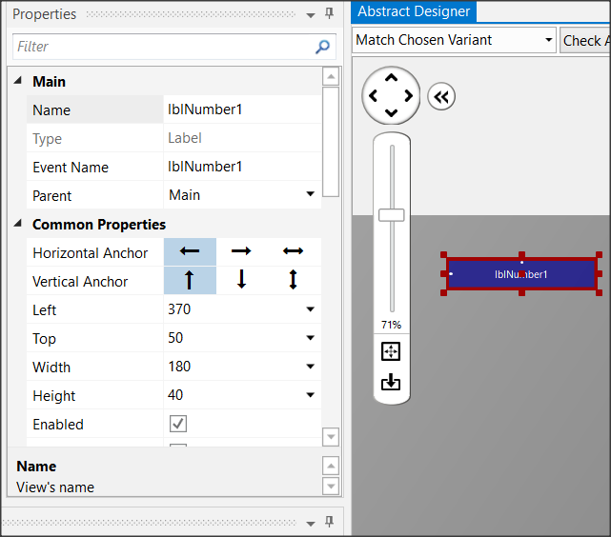
Now scroll down the Properties and set:
Figure Labels
- Width: 180
- Height: 30
- Text: First Number
- Allignment: CENTER_LEFT
- Font: SansSerif
- Size: 13
Experiment with the other settings and see it displayed in the preview pane.
Insert a second label or you can also dublicate the first one. Select it and press Ctrl-D. The second method gives a same label as the first one with the same properties except Name Property. Set “lblNumber2” as name and “Second Number” as Text and Create a third label with name “lblTotal” and Text: “Total”.

Inserting a Text Field.
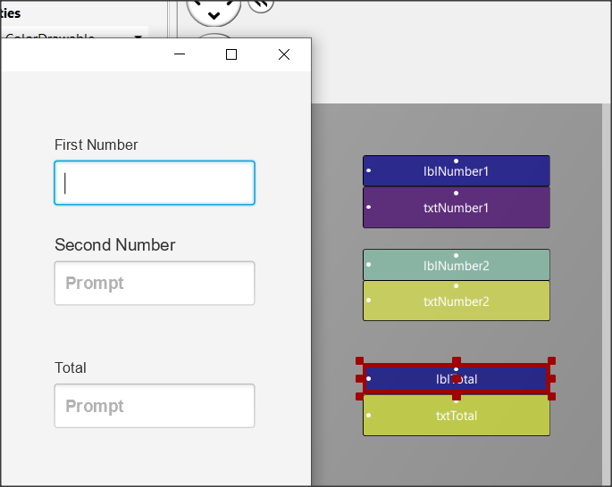
Text Fields are used to import data into the program. There is no restriction on the type of data you can import. From View Menu choose TextField and set:
Figure Text Fields
- Name: txtNumber1
- Width: 180
- Height: 40
- Font: SansSerif
- Bold: checked
Place the textField underneath “First Number” label. Now put a same TextFIeld with name “txtNumber2” and put it underneath label “Second Number”. At the end create a third TextField with Name “txtTotal”. You will probably see something like the Figure 10 Text Fields

Inserting a button
Buttons in an app are used to enable functions. The program detects the click and then executes appropriate commands depending on the button pressed.
For each button you can set different features such as size, color, shape, etc. to stand out on your screen and be easily detected by users of your app.
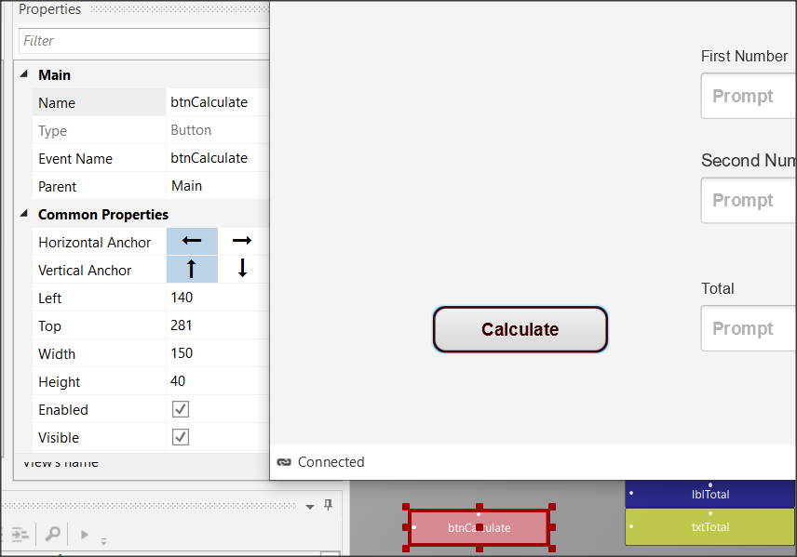
From the Views menu select Button, and then set:
Figure Buttons
- Name: btnCalculate
- Width: 150
- Height: 40
- Border Color: #3C0000
- Border Width: 2
- Corner Radius: 20
- Text: Calculate
- Text Color: #FF3C0000
- Font: SansSerif
- Size: 15
- Bold: checked
Remember
File -> Save (or Ctrl – S) every time you make something valuable!

Inserting a Pane
You can use a Pane to visually group specific objects on the screen you're drawing. The pane displays a frame, and you can specify properties such as color, border, fill, etc. You can also use it at a very small height (1 or 2) to display a single line on your screen.
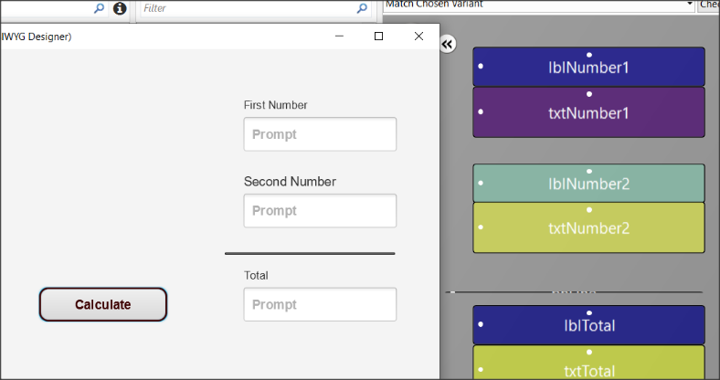
This example is used to draw a line before the total. From menu AddView insert Pane and set:
Figure Pane
- Name: pnLine
- Width: 180
- Height: 1
- Border Color: #000000
- Border Width: 2

Now from menu File save the form. The form has already a name (MainPage) so you don’t need to give an other name.

Excercises
- Use the designer to create the following wireframes.
Teachers tip
This is the fun part. You can also leave students free to experiment with views.

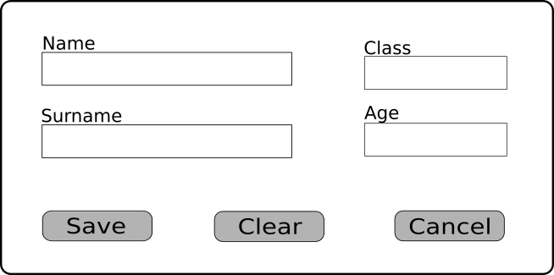

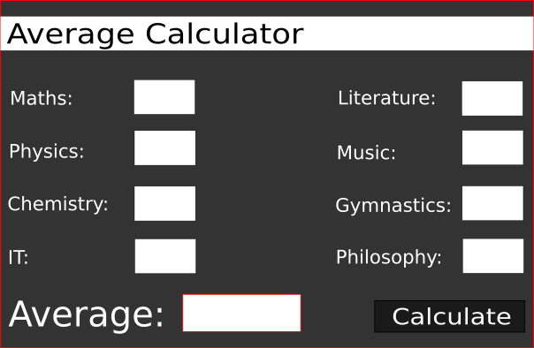

- Think and design your own Dream Application. Give it a name, create a wireframe in your notebook and create the Design View.

